Practice for Chapter 5 Node.js
Q1. Follow the video in 5.6.1 to create your first application for Node.js. Remember to install the necessary software first.

Q2. Follow the video in 5.6.2 to create the application for Node.js.
- Follow the video to make sure the application is running correct
- Then, use JavaScript arrow function for the callback instead of requestListener function.
- Can you get it working as expected?

Q3. Follow the video in 5.6.4 to create the application for Node.js. This application implement GET method and form submission. Make sure you have both.

Q4. Extending the application in Q3, add the following fields to the input form:
- Name
- Password
- Date of birth (use date type)
- Gender (use radio button)
Display the submitted data using table.
Question: can you see the password in the URL? What is the problem with submitting confidential data using GET method?

Q5. Repeat question 4 but using POST method to submit. Refer to 5.6.5
- Modify your form to submit the correct data.
- Add processing logic for POST method to your Node.js backend
- You will need to extract the data from “body” (as described in 5.6.5) using string split function you have learnt in JavaScript.

Q6. Using the knowledge you learned in Chapter 3 practice Question 8 Part D, create a web page to let user view, search and filter the result in the IMDB_Top_250.csv
This dataset is downloaded from Internet with some minor modifications to change comma to semi colon. Use your code in chapter 3 for movie and you should be able to create the objects as in chapter 3 question 8 part D (unless you hard coded the headers).
Part A: Using your answer (any) from practice above, create the navigation for “/”. It should look like this:
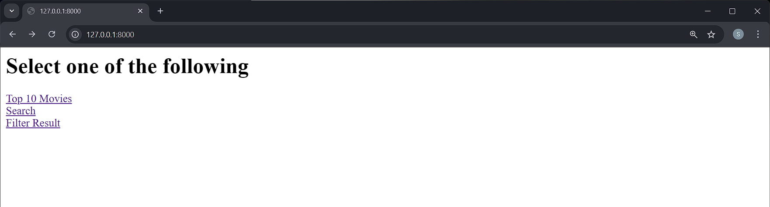

Part B: List the top 10 movies first (start with something simple). If you print out one of the movie objects, it will look like this:
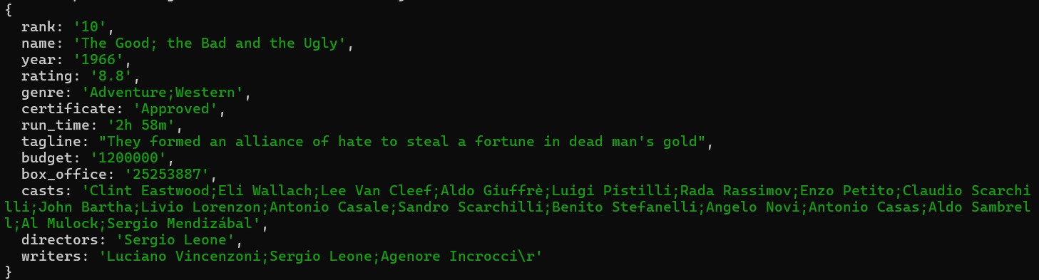

For top 10 movies link, you can use the following suggestions:
- You may want to add the read csv & create movie objects array (from chapter 3) at the beginning of your server script.
- Create an array of 10 objects (movies objects, unsorted) where rank < 10.
- Loop with index from 1 to 10. For each index, you will loop through “array of 10 objects” and find the rank match your index.
- Add this movie object to create table row (one row for each index).

Result:
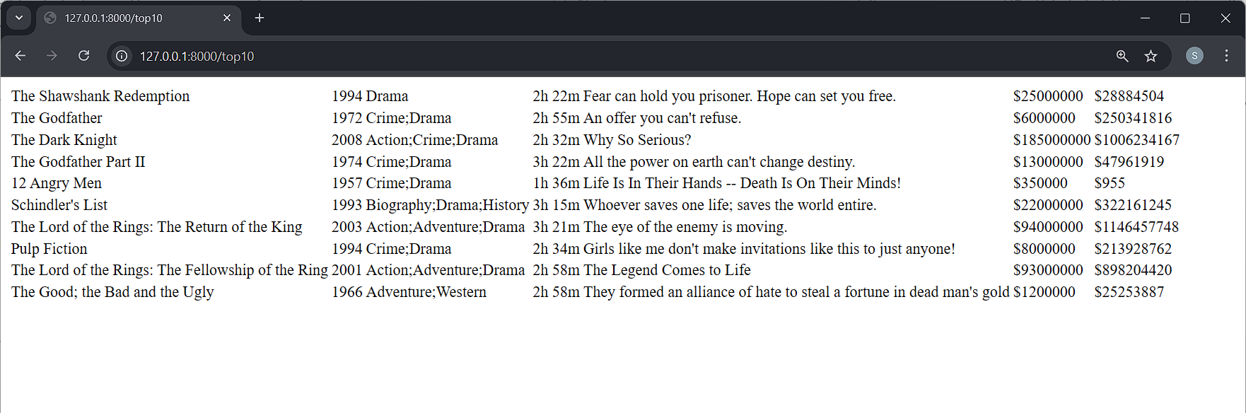

Part C: Search using movie name. You will need 2 URLs. For example,
http://127.0.0.1:8000/search return your search form
http://127.0.0.1:8000/result for form action and server to return the result
you can use the following suggestions based on the URLs above:
- In your server code, add a URL handling code for “/search”
- The response of search is a form with the search input and submit button.
- The form action is “/result” you can choose post or get.
- Next you need to add handling for URL “/result” and form input submitted by user.
- In this handler, you will loop through all the movies objects in the array and look for the title that use input.
Example:
if (req.url == "/search") {
// return form …
}
const info = url.parse(req.url, true);
if (req.method == "GET" && info.pathname == "/result"){
// return the movie information … e.g. in list
}
The result: (search for “The Godfather”)
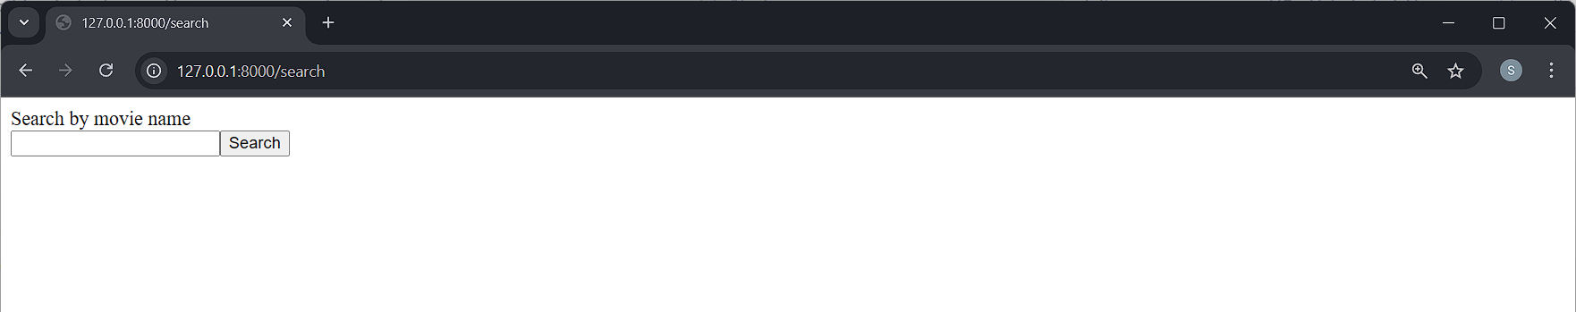
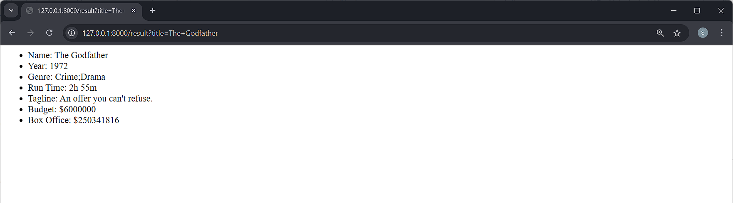

Part D: Use filter to show movies list. Similar, you can use 2 URLs for filter – form and form action submission.
you can use the following suggestions:
- Use indexOf to look for the existence of the given genre in the movie object.
- Is the year within range? This is an interesting problem. Will leave the challenge to you to implement it. Maybe you should look for your inspiration at chapter 3.4.2?

Result:
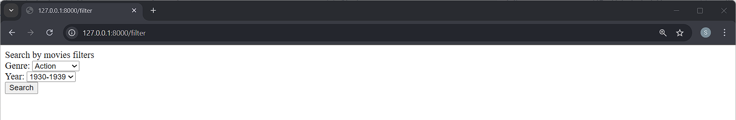
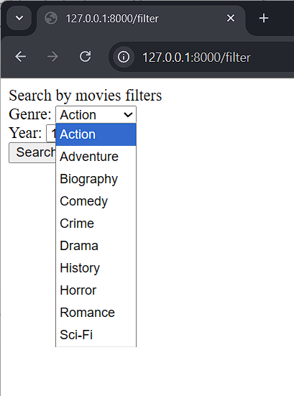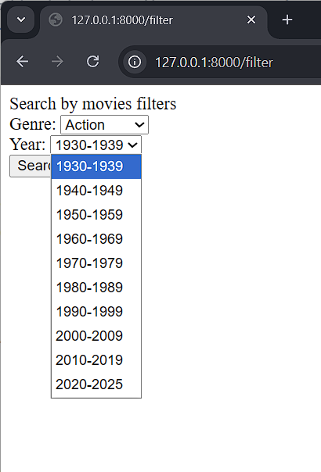
Genre and year are not the complete list but it is enough to illustrate the application.
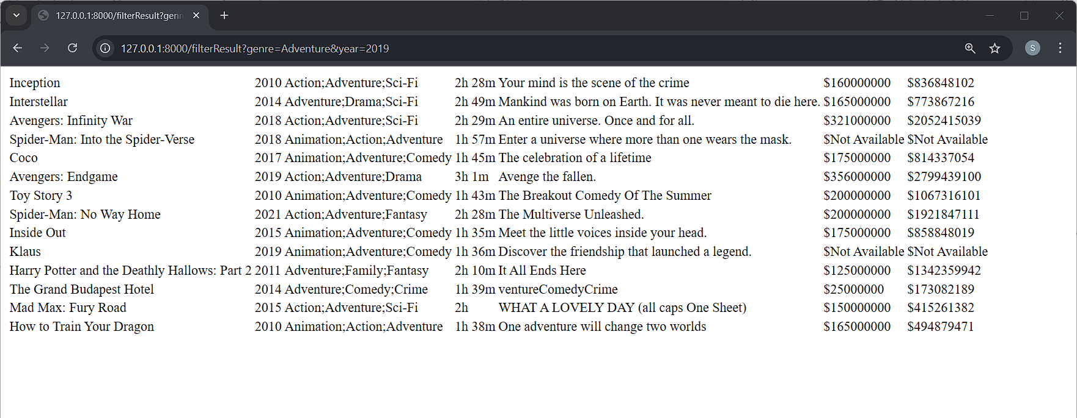
The result is shown in table. See URL for search conditions.

